**Nome:_____________________________________________________________________________________Nº_______________**

**9º EXERCÍCIO - RESOLVA OS EXERCÍCIOS ABAIXO COM INSTRUÇÕES SQL**

**Relacionamento entre Tabelas**

**As suas tabelas devem conter os seguintes dados para que possamos efetuar consultas:**

N

1

aluga

FILME

CLIENTE

**FILME chave estrangeira**

|  |  |  |  |  |
| --- | --- | --- | --- | --- |
| **codfilme** | **codcliente** | **filme** | **genero** | **ano** |
| auto-incrementável | 2 | Shrek 3 | comédia | 2007 |
| auto-incrementável | 3 | Ela dança eu danço | drama | 2007 |
| auto-incrementável | 4 | Homem Aranha 3 | aventura | 2006 |
| auto-incrementável | 4 | Medo ponto com | suspense | 2000 |
| auto-incrementável | 1 | A era do gelo | infantil | 2001 |

**CLIENTE**

**Chave de cliente**

|  |  |  |  |  |  |  |
| --- | --- | --- | --- | --- | --- | --- |
| **codcliente** | **nome** | **RG** | **CPF** | **endereço** | **telefone** | **cidade** |
| auto-incrementável | Regina Duarte | 1234 | 5678 | Rua X, 90 | 3491-2929 | Tupã |
| auto-incrementável | Caio Castro | 2345 | 6789 | Rua T, 879 | 3461-2020 | Marília |
| auto-incrementável | Mariana Rios | 3456 | 7891 | Rua Z, 67 | 3491-2525 | Tupã |
| auto-incrementável | Bruno GIssoni | 4567 | 9876 | Rua K, 78 | 3471-3636 | Bastos |

t *r

1. Selecione todas as colunas de ambas as tabelas: cliente e filme:

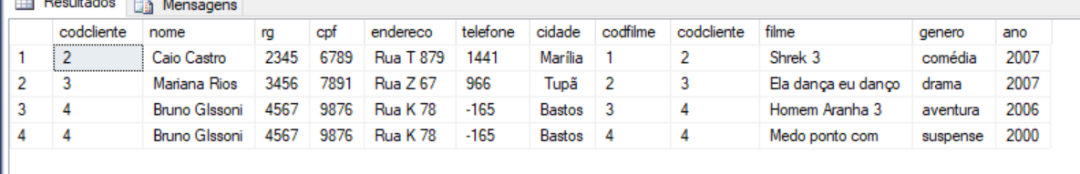

Função para juntar duas tabelas = select *from cliente555 inner join filme555 on cliente555.codcliente=filme555.codcliente

**______________________________________________________________________________________________________________2)** Selecione o nome do filme e o gênero que é suspense:

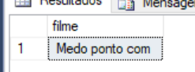

select filme from filme555 where genero ='suspense'

**______________________________________________________________________________________________________________3)** Selecione os nomes dos clientes que moram em Tupã:

**______________________________________________________________________________________________________________**

**4)** Selecione o nome do cliente que assistiu o filme “**Shrek 3**”:

**______________________________________________________________________________________________________________**______________________________________________________________________________________________________________

**5)** Selecione o nome, o RG e o CPF do cliente que alugou o gênero “**drama**”:

**_______________________________________________________________________________________________________________**_____________________________________________________________________________________________________________

**6)** Selecione o código do cliente e o telefone dos clientes que alugaram “**Medo ponto com**” ou “**Homem Aranha 3**”:

**_______________________________________________________________________________________________________________**_____________________________________________________________________________________________________________

**7)** Selecione o nome do cliente, o rg e o cpf dos clientes que alugaram um filmes cujo gênero é suspense :

**_______________________________________________________________________________________________________________**_____________________________________________________________________________________________________________

**8)** Selecione o codigo do cliente e o nome do cliente que alugaram filmes de 2007:

**_______________________________________________________________________________________________________________**_____________________________________________________________________________________________________________

**9)** Apague da tabela o filme **A era do gelo**:

**______________________________________________________________________________________________________________**

**10)** Apague da tabela o cliente **Bruno Gissoni:**

**______________________________________________________________________________________________________________**